EWMA correlation: NZDUSD and USDCAD
Method 06 / daily log returns / lambda = 0.94 / Alpari D1 full available history

Study setup
Logical pair: NZDUSD , USDCAD
Broker symbols: NZDUSD_i , USDCAD_i
Snapshot: 2026-11-03_majors_alpari_D1
Timeframe: D1
Matched return window: 1999-01-05 to 2026-11-02 (UTC bar dates)
Matched return count n: 7190
Dropped unfinished last bar dated 2026-11-03 UTC after a tick-volume check against the prior complete day.
Lambda: 0.94 (today weight 0.06)
Burn-in ignored in path summaries and chart: first 60 updates
Mean adjustment: each leg demeaned by its mean on the matched rows
Seeds: c_0 = v_x,0 = v_y,0 = 0
Complete matched rows (Excel): NZDUSD-USDCAD_EWMA_D1.xlsx
Complete matched rows (HTML table): NZDUSD-USDCAD_EWMA_D1_data.html

Method carried forward
EWMA correlation updates covariance and variances of mean-adjusted daily log returns of close, ln(close_t / close_t-1), with lambda = 0.94 (6% weight on today's product or square, 94% on yesterday's EWMA state). Quotes are not inverted. Each leg is demeaned by its mean on the matched rows; that mean uses the full sample, so the rho path is a full-sample description, not a live filter. Seeds start at zero. Path summaries and the chart ignore the first 60 updates so the zero seed has faded. The headline is rho on the last day. rho is symmetric under swap of the two symbols. A high |rho| does not prove cause, lead-lag, or a trading signal. Today's return sits inside today's rho, so the estimate can only inform a later decision. Same-sample Pearson r is a side check only.

Results
Latest EWMA rho: -0.270371
Post-burn-in path (n=7130): mean=-0.541340, median=-0.569786, min=-0.925510, max=0.328489, std=0.193494
Share of post-burn-in days with |rho| >= 0.4: 77.41%; |rho| >= 0.7: 22.37%
Same-sample Pearson r: -0.587831
Latest rho minus r: 0.317460

Conclusion
Over 7190 matched daily log-return rows for NZDUSD and USDCAD (broker quote directions unchanged), latest EWMA rho with lambda=0.94 is -0.2704 (negative, weak recent linear link in this sample). After a 60-day burn-in, path mean is -0.5413, std is 0.1935, and the range is [-0.9255, 0.3285]. Same-sample Pearson r is -0.5878 (latest rho minus r = 0.3175). This does not establish cause, lead-lag, or a lasting trading rule.

Charts
Daily closes

Daily log returns
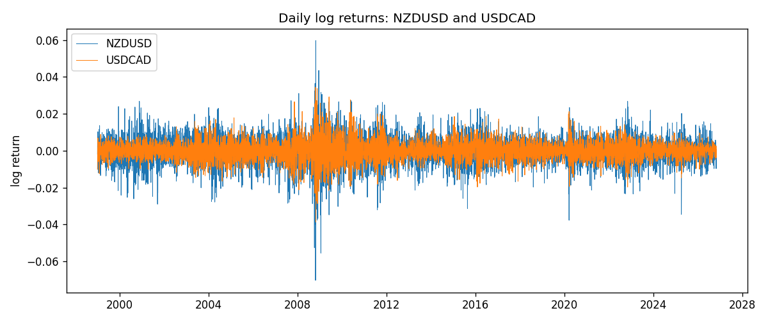
EWMA rho path with Pearson r reference
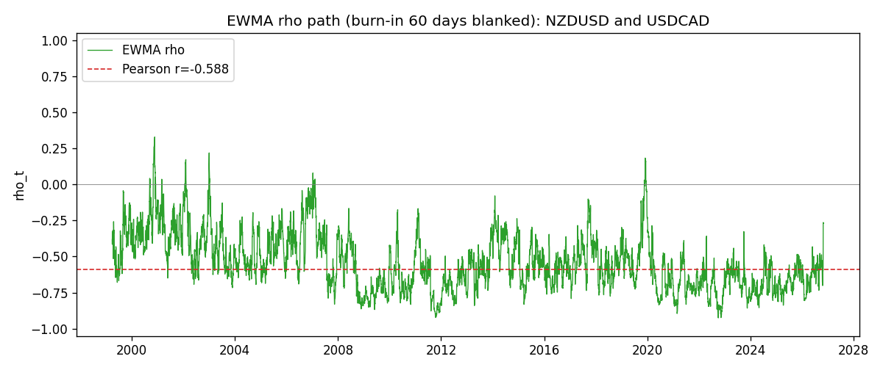

Data report
Every matched row that entered the EWMA recursion is stored in the sibling Excel workbook named NZDUSD-USDCAD_EWMA_D1.xlsx. That file is the complete data archive for redrawing charts. Embedding all rows as a Word table is impractical at this length; the Word file holds the column list, column summaries, and the first and last 15 matched rows.
Columns: time, NZDUSD_open, USDCAD_open, NZDUSD_high, USDCAD_high, NZDUSD_low, USDCAD_low, NZDUSD_close, USDCAD_close, NZDUSD_tick_volume, USDCAD_tick_volume, NZDUSD_spread, USDCAD_spread, NZDUSD_real_volume, USDCAD_real_volume, NZDUSD_log_return, USDCAD_log_return, NZDUSD_x_demeaned, USDCAD_y_demeaned, c_t, v_x, v_y, rho_t
Column summaries (matched calculation rows)
column | count | mean | std | min | 25% | 50% | 75% | max
NZDUSD_open | 7190 | 0.6563919 | 0.10821436 | 0.3913 | 0.5912925 | 0.6684 | 0.7249075 | 0.88218
USDCAD_open | 7190 | 1.2668559 | 0.16897553 | 0.9168 | 1.118445 | 1.298545 | 1.37213 | 1.6183
NZDUSD_high | 7190 | 0.66030697 | 0.10871111 | 0.3961 | 0.5947025 | 0.67202 | 0.72936 | 0.88421
USDCAD_high | 7190 | 1.2717549 | 0.16892987 | 0.9336 | 1.122975 | 1.30394 | 1.37655 | 1.619
NZDUSD_low | 7190 | 0.65270307 | 0.10781082 | 0.3897 | 0.5880525 | 0.664185 | 0.720965 | 0.87988
USDCAD_low | 7190 | 1.2623003 | 0.16901312 | 0.9056 | 1.114125 | 1.293585 | 1.36785 | 1.6102
NZDUSD_close | 7190 | 0.65646372 | 0.10821182 | 0.3907 | 0.5915625 | 0.66842 | 0.725015 | 0.8822
USDCAD_close | 7190 | 1.266877 | 0.16895077 | 0.916 | 1.118165 | 1.298615 | 1.372425 | 1.6137
NZDUSD_tick_volume | 7190 | 68672.777 | 123109.57 | 16 | 5561.25 | 33864.5 | 58508 | 1127682
USDCAD_tick_volume | 7190 | 80995.8 | 147287.89 | 37 | 5534 | 40938 | 71622.5 | 1410818
NZDUSD_spread | 7190 | 30.299444 | 25.655426 | 0 | 9 | 17 | 50 | 80
USDCAD_spread | 7190 | 23.448679 | 18.267866 | 0 | 9 | 17 | 40 | 60
NZDUSD_real_volume | 7190 | 1.6692087e+10 | 8.4955308e+10 | 0 | 0 | 0 | 0 | 2.705649e+12
USDCAD_real_volume | 7190 | 1.8371592e+10 | 9.6675129e+10 | 0 | 0 | 0 | 0 | 2.5751613e+12
NZDUSD_log_return | 7190 | 6.02e-06 | 0.00764513 | -0.07027433 | -0.00425619 | 0.00022347 | 0.00457637 | 0.05966839
USDCAD_log_return | 7190 | -9.38e-06 | 0.0051433 | -0.03859748 | -0.00283202 | 5.381e-05 | 0.00272817 | 0.03436319
NZDUSD_x_demeaned | 7190 | 0 | 0.00764513 | -0.07028035 | -0.00426221 | 0.00021745 | 0.00457035 | 0.05966237
USDCAD_y_demeaned | 7190 | 0 | 0.0051433 | -0.0385881 | -0.00282264 | 6.318e-05 | 0.00273755 | 0.03437256
c_t | 7190 | -2.311e-05 | 3.413e-05 | -0.00042867 | -2.396e-05 | -1.427e-05 | -8.87e-06 | 9.87e-06
v_x | 7190 | 5.84e-05 | 5.901e-05 | 2.1e-07 | 3.046e-05 | 4.224e-05 | 6.689e-05 | 0.00086266
v_y | 7190 | 2.644e-05 | 3.123e-05 | 3.68e-06 | 1.172e-05 | 1.801e-05 | 2.909e-05 | 0.00040855
rho_t | 7190 | -0.53877512 | 0.19606848 | -0.92551044 | -0.68705842 | -0.56777704 | -0.41514793 | 1
First 15 matched rows (selected columns)
time | NZDUSD_close | USDCAD_close | NZDUSD_log_return | USDCAD_log_return | NZDUSD_x_demeaned | USDCAD_y_demeaned | c_t | v_x | v_y | rho_t
1999-01-05 | 0.5372 | 1.5123 | -0.0018597736 | -0.010131666 | -0.0018657947 | -0.010122289 | 1.1331667e-06 | 2.0887139e-07 | 6.1476437e-06 | 1
1999-01-06 | 0.5383 | 1.5118 | 0.0020455609 | -0.0003306769 | 0.0020395399 | -0.00032129999 | 1.0258585e-06 | 4.4592248e-07 | 5.7849791e-06 | 0.63871465
1999-01-07 | 0.5417 | 1.5141 | 0.0062963171 | 0.0015202092 | 0.0062902961 | 0.0015295861 | 1.5415999e-06 | 2.7932366e-06 | 5.5782584e-06 | 0.39054269
1999-01-08 | 0.5414 | 1.511 | -0.00055396548 | -0.0020495197 | -0.00055998652 | -0.0020401428 | 1.5176511e-06 | 2.6444575e-06 | 5.4932938e-06 | 0.39818714
1999-01-11 | 0.547 | 1.5057 | 0.010290425 | -0.0035137769 | 0.010284404 | -0.0035044 | -7.3584796e-07 | 8.8319282e-06 | 5.9005454e-06 | -0.10193287
1999-01-12 | 0.5441 | 1.5157 | -0.0053157489 | 0.0066194721 | -0.00532177 | 0.006628849 | -2.8083297e-06 | 1.0001287e-05 | 8.183011e-06 | -0.31042993
1999-01-13 | 0.5387 | 1.5226 | -0.0099742238 | 0.0045420214 | -0.0099802448 | 0.0045513983 | -5.3652741e-06 | 1.5377527e-05 | 8.934944e-06 | -0.45772302
1999-01-14 | 0.5386 | 1.5332 | -0.00018564931 | 0.0069376546 | -0.00019167034 | 0.0069470315 | -5.12325e-06 | 1.4457079e-05 | 1.1294522e-05 | -0.40093257
1999-01-15 | 0.5382 | 1.5245 | -0.00074294208 | -0.0056905671 | -0.00074896312 | -0.0056811902 | -4.5605549e-06 | 1.3623311e-05 | 1.2553406e-05 | -0.34873502
1999-01-18 | 0.5372 | 1.526 | -0.0018597736 | 0.00098344542 | -0.0018657947 | 0.00099282233 | -4.3980658e-06 | 1.3014784e-05 | 1.1859344e-05 | -0.35400787
1999-01-19 | 0.5382 | 1.5302 | 0.0018597736 | 0.002748513 | 0.0018537526 | 0.0027578899 | -3.8274351e-06 | 1.2440081e-05 | 1.160414e-05 | -0.3185589
1999-01-20 | 0.5404 | 1.5211 | 0.0040793678 | -0.0059646885 | 0.0040733468 | -0.0059553116 | -5.0532719e-06 | 1.2689205e-05 | 1.3035836e-05 | -0.3929036
1999-01-21 | 0.5426 | 1.5146 | 0.0040627941 | -0.0042823796 | 0.0040567731 | -0.0042730027 | -5.7901518e-06 | 1.2915297e-05 | 1.3349199e-05 | -0.44097111
1999-01-22 | 0.5361 | 1.5184 | -0.012051689 | 0.0025057712 | -0.01205771 | 0.0025151481 | -7.2623583e-06 | 2.0863682e-05 | 1.2927805e-05 | -0.44220107
1999-01-25 | 0.5342 | 1.5197 | -0.0035504102 | 0.00085579808 | -0.0035564312 | 0.000865175 | -7.0112329e-06 | 2.0370754e-05 | 1.2197049e-05 | -0.44479866
Last 15 matched rows (selected columns)
time | NZDUSD_close | USDCAD_close | NZDUSD_log_return | USDCAD_log_return | NZDUSD_x_demeaned | USDCAD_y_demeaned | c_t | v_x | v_y | rho_t
2026-10-13 | 0.56127 | 1.4214 | 0.0047326165 | -0.0046395653 | 0.0047265955 | -0.0046301884 | -6.587836e-06 | 1.6959067e-05 | 7.213426e-06 | -0.59562238
2026-10-14 | 0.55918 | 1.42356 | -0.0037306483 | 0.0015184751 | -0.0037366693 | 0.001527852 | -6.5351105e-06 | 1.6779285e-05 | 6.9206803e-06 | -0.60644555
2026-10-15 | 0.56185 | 1.41843 | 0.0047634855 | -0.0036101503 | 0.0047574644 | -0.0036007734 | -7.1708369e-06 | 1.7130536e-05 | 7.2833736e-06 | -0.64197494
2026-10-16 | 0.56509 | 1.41357 | 0.0057501001 | -0.0034322068 | 0.0057440791 | -0.0034228298 | -7.920247e-06 | 1.808237e-05 | 7.5493171e-06 | -0.67788685
2026-10-19 | 0.56616 | 1.41091 | 0.0018917133 | -0.0018835331 | 0.0018856922 | -0.0018741562 | -7.6570771e-06 | 1.7210778e-05 | 7.3071057e-06 | -0.68279459
2026-10-20 | 0.56827 | 1.40569 | 0.0037199341 | -0.0037066008 | 0.0037139131 | -0.0036972239 | -8.0215226e-06 | 1.7005721e-05 | 7.6888473e-06 | -0.70150161
2026-10-21 | 0.57003 | 1.4045 | 0.0030923331 | -0.00084691787 | 0.0030863121 | -0.00083754096 | -7.695326e-06 | 1.6556897e-05 | 7.2696049e-06 | -0.70142646
2026-10-22 | 0.56815 | 1.40081 | -0.0033035227 | -0.0026307268 | -0.0033095437 | -0.0026213499 | -6.7130781e-06 | 1.6220668e-05 | 7.2457172e-06 | -0.61922239
2026-10-23 | 0.56991 | 1.40085 | 0.0030929853 | 2.85545e-05 | 0.0030869642 | 3.7931412e-05 | -6.3032678e-06 | 1.5819189e-05 | 6.8110605e-06 | -0.60724828
2026-10-26 | 0.56826 | 1.40093 | -0.0028993932 | 5.7106554e-05 | -0.0029054142 | 6.6483466e-05 | -5.9366615e-06 | 1.5376523e-05 | 6.402662e-06 | -0.59831918
2026-10-27 | 0.56811 | 1.40449 | -0.00026399852 | 0.0025379458 | -0.00027001956 | 0.0025473227 | -5.6217314e-06 | 1.4458306e-05 | 6.4078335e-06 | -0.58405773
2026-10-28 | 0.56261 | 1.39911 | -0.0097283914 | -0.0038379274 | -0.0097344125 | -0.0038285505 | -3.0483062e-06 | 1.9276335e-05 | 6.9028314e-06 | -0.26426078
2026-10-29 | 0.56296 | 1.39895 | 0.00062190714 | -0.00011436495 | 0.00061588611 | -0.00010498804 | -2.8692874e-06 | 1.8142514e-05 | 6.4893229e-06 | -0.26443908
2026-10-30 | 0.56307 | 1.39751 | 0.00019537668 | -0.0010298736 | 0.00018935564 | -0.0010204967 | -2.7087244e-06 | 1.7056114e-05 | 6.1624483e-06 | -0.26420932
2026-11-02 | 0.56161 | 1.39837 | -0.0025962955 | 0.00061519094 | -0.0026023166 | 0.00062456786 | -2.6437203e-06 | 1.6439071e-05 | 5.8161065e-06 | -0.27037137

